**Exercise -3 Introduction to Database**

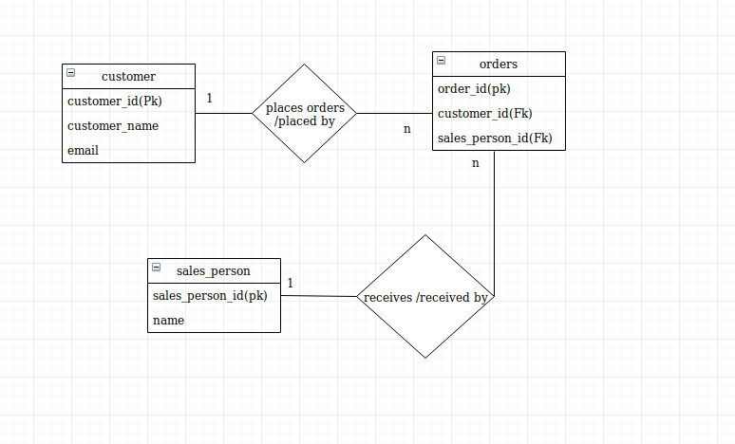

Ques 1 Create Database

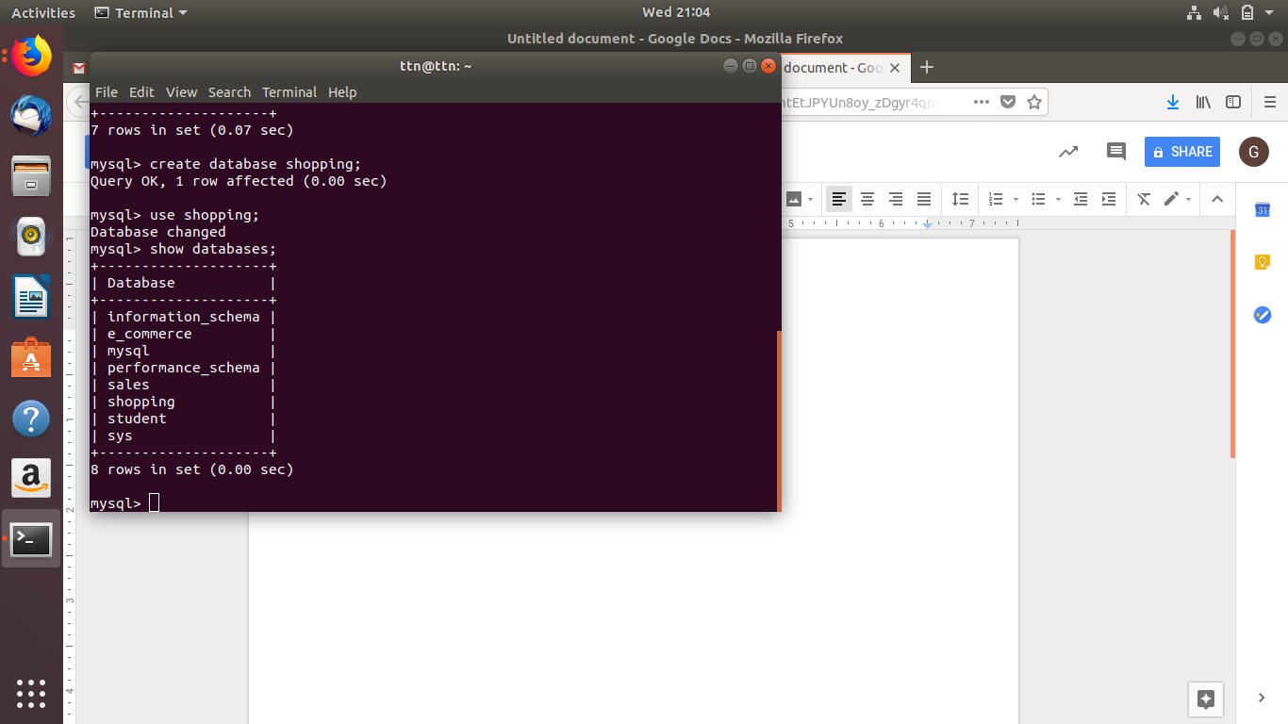

Ques 3 Draw tables

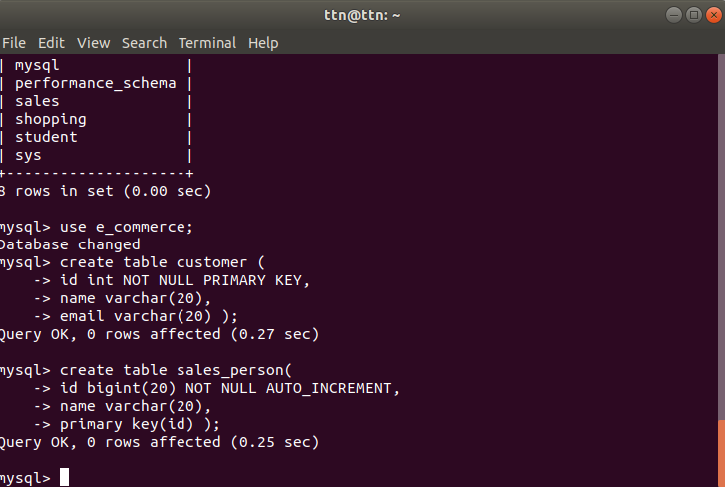

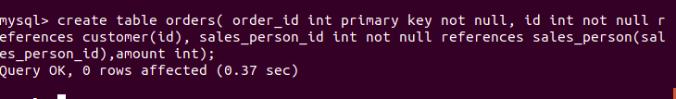

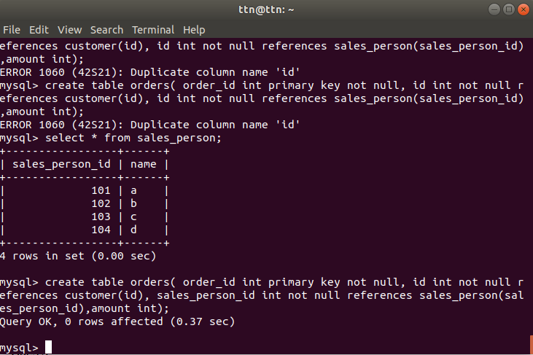

Ques 4 Input sample data

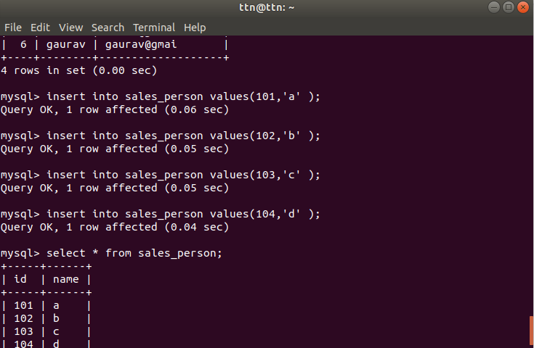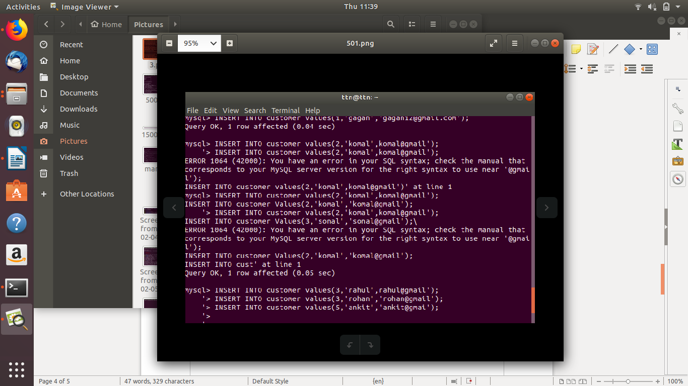

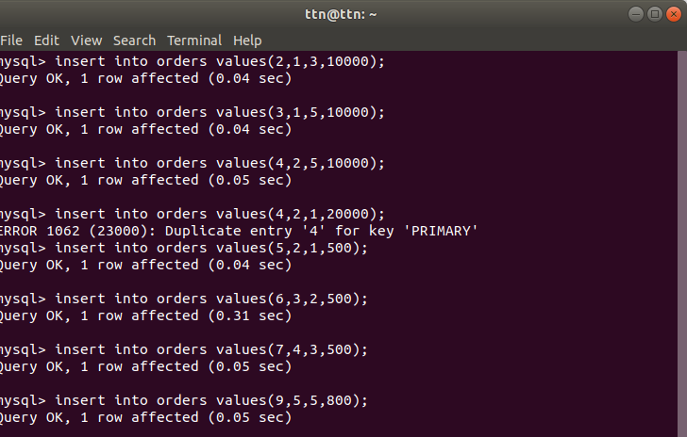

Ques 5 Find the sales person have multiple orders.

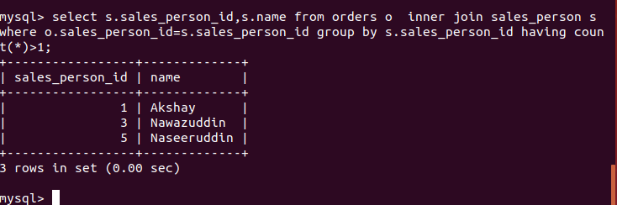

Ques 6 Find the all sales person details along with order details

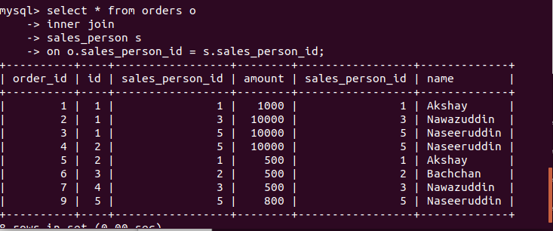

Ques 7 Creating Index

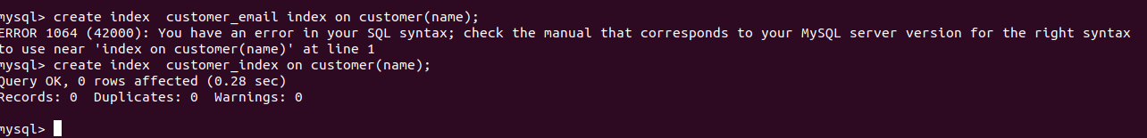

Ques 8 Displaying index

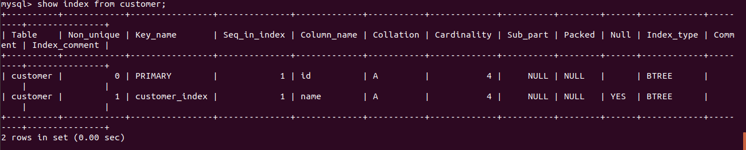

Ques:9 Find the order number, sale person name, along with the customer to whom that order belongs to

